**Volunteering Before Job Applications (PROJECT GLIMPSE)**

Normally, at a university, there are many **International graduate students** looking for jobs after they graduate. This makes it difficult for people who are new to applying for jobs, and interviews. And, with no experience whatsoever, they end up confused in job applications, and waste their time looking for answers which they may not find by their own. If we have a volunteering management system where people can work for professors till they get a job then it might help students to figure out their goals, find time to gain professional experience, understand the paperwork for filing documents for employment with the help from professors. Even while working for these positions they have a chance to showcase their skills and figure out what they want to do in future.

Imagine this is your product, and you want to start marketing. The first thing you gotta do is create a **landing page prototype**(Instructions for the same is attached below in this document), and in this project you will create multiple pages such as About, Services/ Features, Gallery, Testimonials, Forum/ Blog, and Contact. After this, you will move on to the actual **product screens** for designed system (details have been mentioned below in this document). The authentication module will have a login as well as registration page/ modal.

The attached screens along with this document in the current directory will have to be implemented to get full points on your assignments. You might see everything grey in here, don’t worry, you will be using the color combination palette I have designed, and which is mentioned below here in this document.

**It is not allowed to use bootstrap** till assignment 4, but you can use it on your 5th assignment (LARAVEL).

I will be seeing the external, and internal css on your code during the demos. Please make sure, you write on your own to understand it better. All the screen images will be attached inside this directory with this document.

Before starting to make the landing page prototype, and the internal product screens. You should start implementing the DB Schema, E-R Diagram, and make a report for the **first assignment**  with relevant diagrams, and summary of the project you will be implementing.

The Volunteering Management System will have four different kind of users:

1. Volunteer / Student **(Type 0)**

* Has a login / register page.
* After login / registration, students can apply to work for a professor with a form attached below titled “Student / Volunteer Registration form”.
* After registration, wait for professor, and department approval.
* Can complete a task once assigned by the professor.

1. Professor **(Type 1)**

* Has a login / register page.
* Can see list of applied students, and can recruit them, and wait for department approval to assign tasks.
* **The list / tabular must have all the registered fields filled by the volunteer / students while applying, so the professor can have a look at the student, and her/his resume.**
* Can add tasks for approved students / volunteers.
* Can remove a volunteer.

1. Site Administrator / Department (Approval) **(Type 2)**

* Has a login / register page.
* Department can see a list of students, forwarded by professors, and can approve, or reject them.
* If rejected by department, the professor will see the student status as rejected on their dashboard.

1. Admin **(Type 3)**

* Has a login page / register page.
* Can update users.
* Can delete users.

**INTERNAL PAGES ( AFTER LOGIN / REGISTRATION ):**

**Authentication Pages / Modal:**

1. LOGIN (Volunteer, Professor, Department, Admin)
2. REGISTER (Volunteer, Professor, Department, Admin)

**Volunteer Dashboard:**

* Can see tasks page.
* Once the Student/ Volunteer registers, she/ he can apply for working under a professor.

**Note:** Volunteer will have two screens, one where they see tasks allotted by the professor. And, other where they have a page / form to apply for a job under a professor. The form will be titled as “Volunteer Job Application form” and it’s a pdf attached in the same directory with this file.

**Professor Dashboard:**

* Can recruit volunteers/ students page.

**Note**: Here in the recruit column, you will add a **check box**, and the professor can recruit the student after ticking the checkbox. This is a sample structure made by me, please ignore duplicates or irrelevant information in here.

You’re welcome to add more screens.

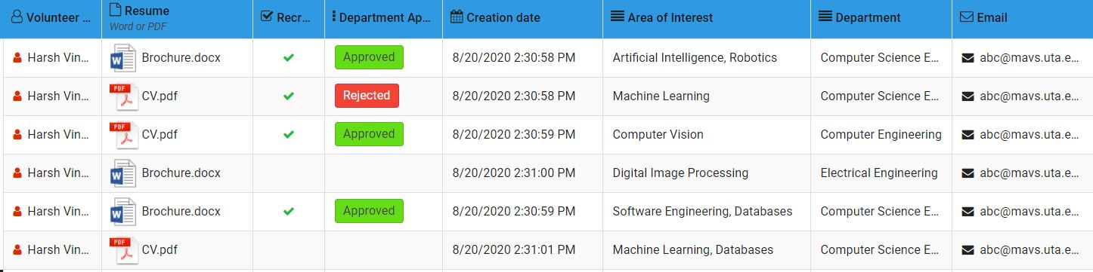

* Can assign tasks to recruited volunteers page.

**Note**: You can make this page with your own ideas, and you’re welcome to come up with your own logic

**Department Dashboard:**

* Can see a list of students forwarded by professor, and the department can approve them accordingly.

**Note:** Here, the department account will have a list of students being referred by the professors, and the department will approve them according to their evaluations. It will only have one screen/ page. You’re welcome to add more screens.

**Admin Dashboard:**

* Can update users.
* Can delete users.

**LANDING PAGE PROTOTYPE:**

**INSTRUCTIONS**:

* Find the project.zip file, and attach all the image files as shown in the following screens.
* Make all the layouts as shown below in separate screens. The idea of this landing page is to show what the product is, and how will it impact the company/ organization after using it.
* Use font-family: Montserrat,sans-serif throughout the website to achieve uniformity
* Try to make responsive div containers to cover mobile, tablet, and laptop/ desktop screens.
* All the below screens has to be present during the demo.
* **Color Combination:**

This color combination has to be used throughout the website. Failure to do so will result in negative points to that assignment.

1. Button Color: #A28089
2. Header Background: #8458B3
3. Footer Background : #444554
4. Text Color: #2A2D34
5. Success / Pass Button : Green
6. Reject / Failed Button : Red
7. **HOMEPAGE**

* Use the “Home.jpg” image from the zipped file.

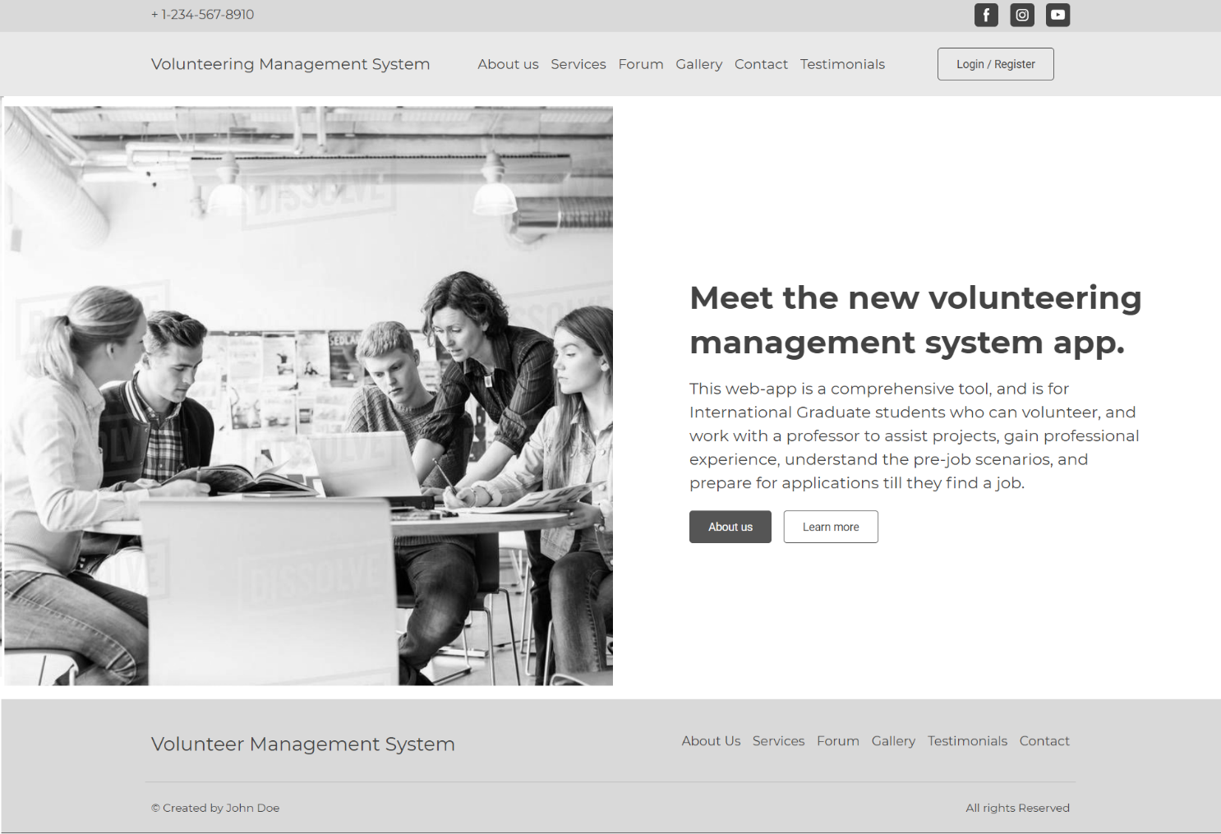

1. **ABOUT US PAGE**

* The about us page layout must have an image on left hand side.
* The content on the right side.
* With 50-50 division of screen, it should accommodate all the things.
* Use the “About.jpg” image from the zipped file.

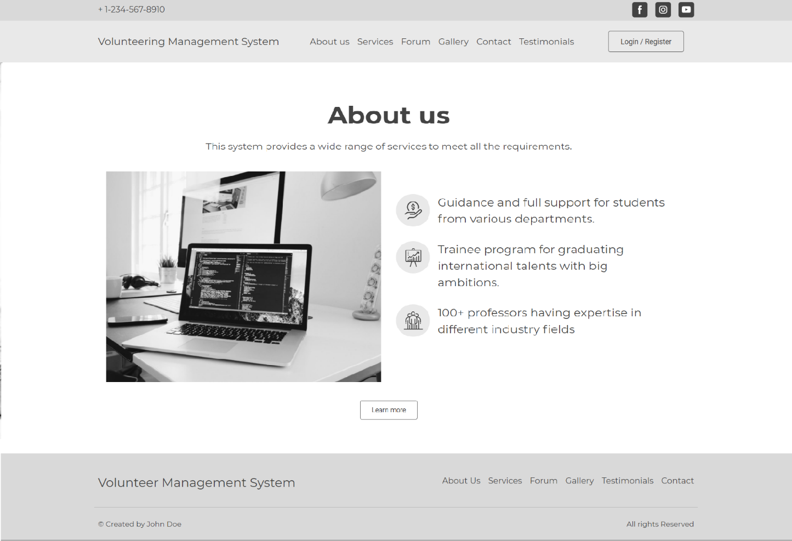

1. **FEATURES/ SERVICES PAGE :**

* All the feature titles as shown below has to be same as depicted.
* You can describe your features as per your understanding, and update the “Lorem Ipsum” text.
* The icons used for these features can be yours, it doesn’t have to be same.

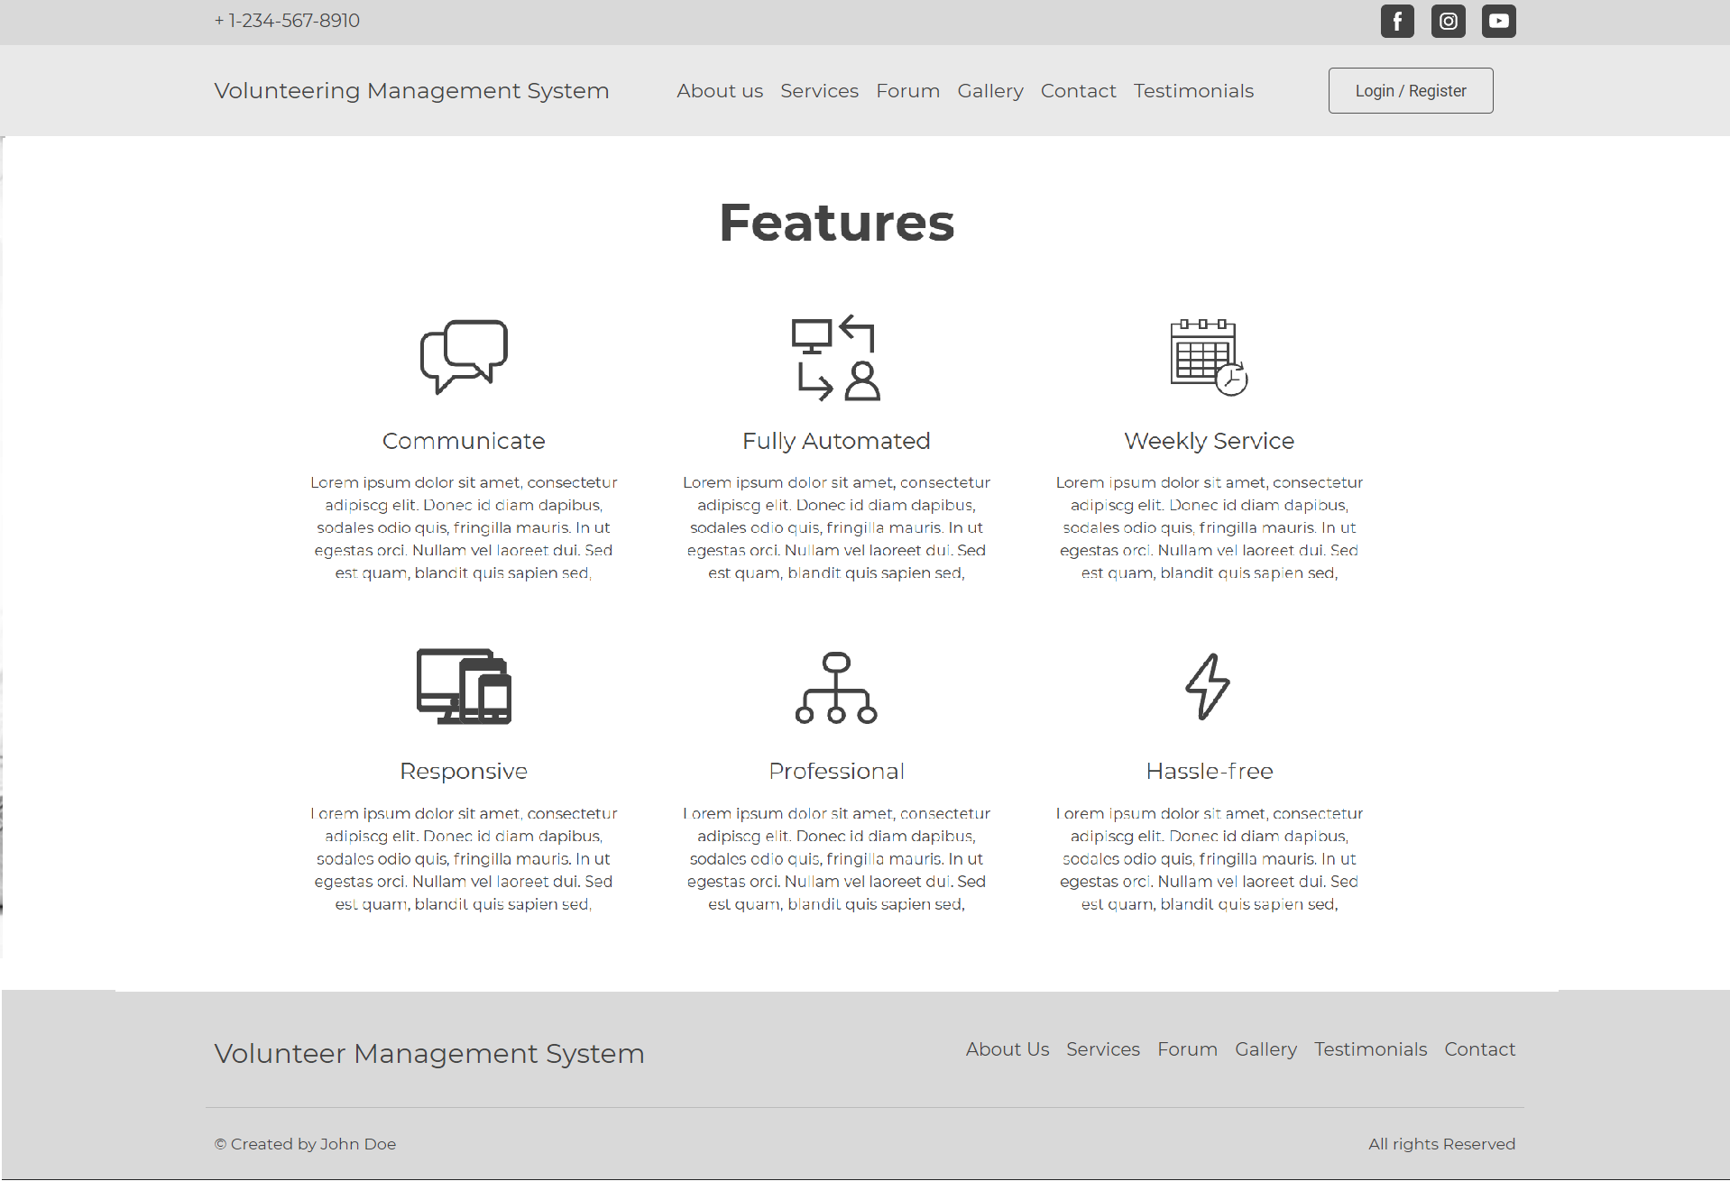

1. **GALLERY PAGE :**

* All the images should be your internal screens like login, register, volunteer dashboard, professor dashboard, department dashboard, and admin dashboard.
* In the starting assignments, you won’t be designing these screens so you can put any relevant images you like.

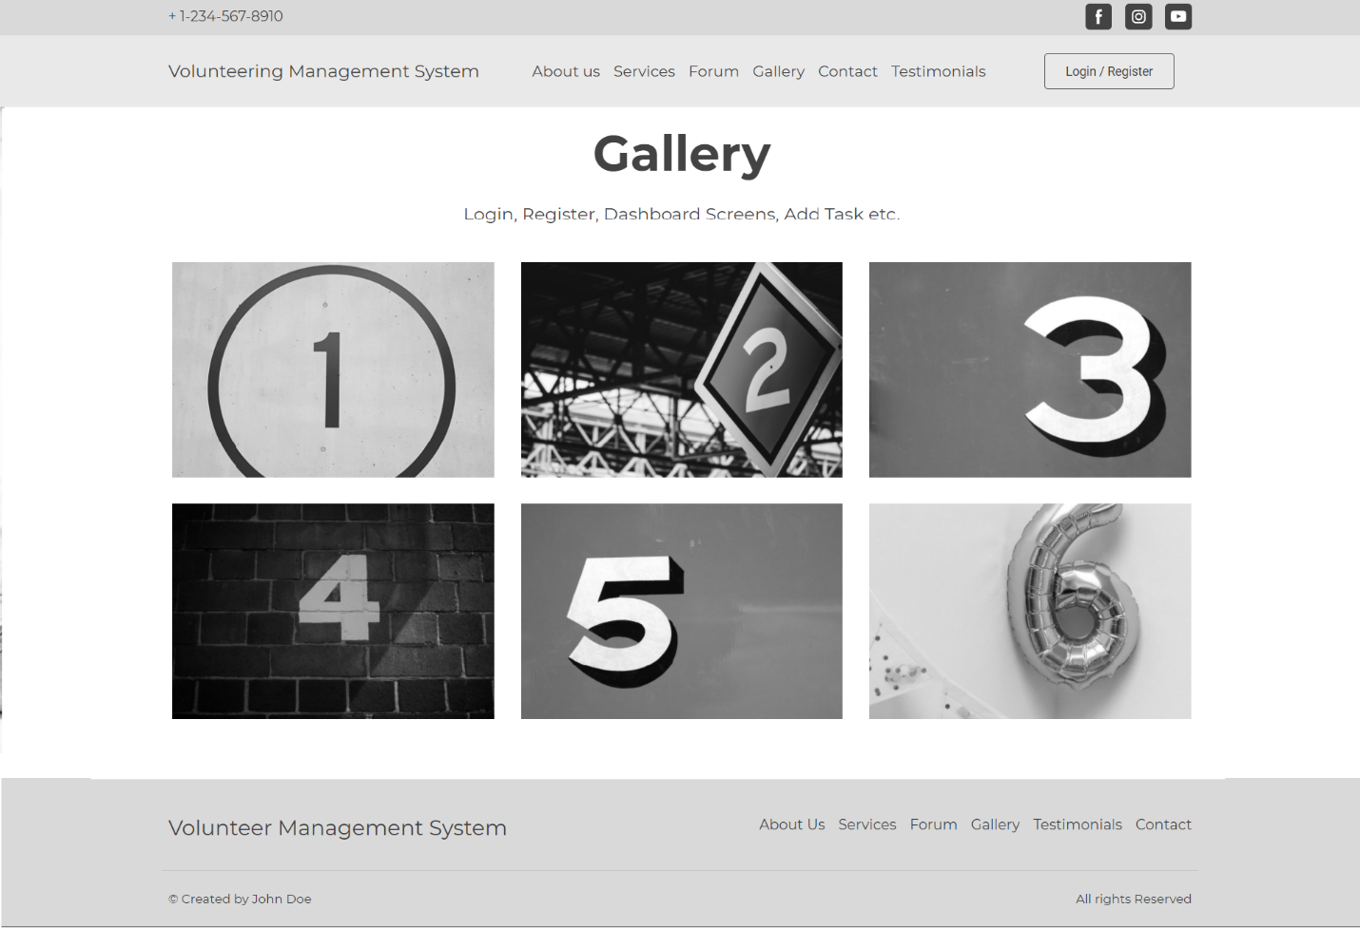

1. **TESTIMONIAL PAGE:**

* You can put three or four testimonials, it can be a slider or it can be as shown below.
* Put some relevant testimonials instead of “Lorem Ipsum” text.

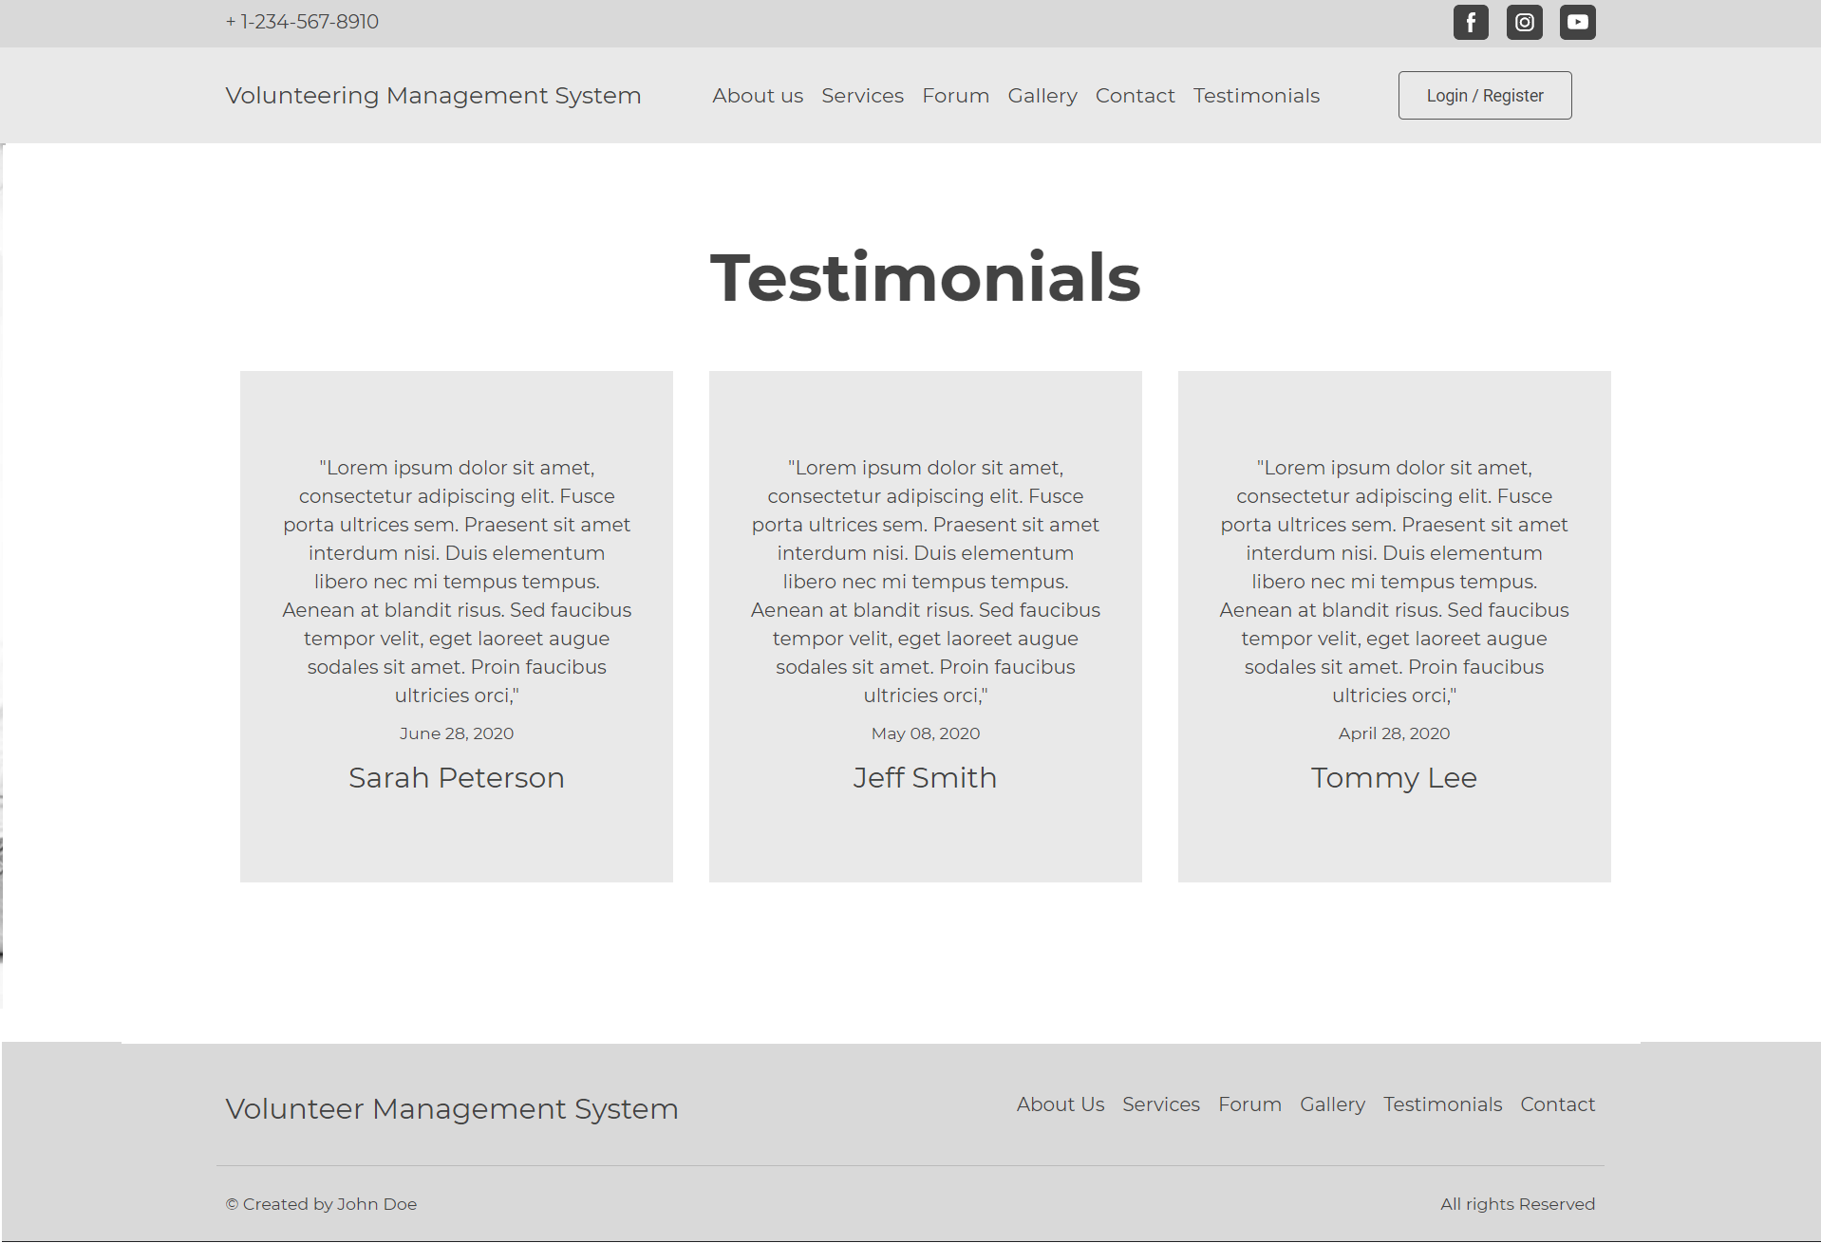

1. **CONTACT US PAGE:**

* Design the layout as below.
* The structure should remain the same.

